**AP Calculus AB Section 3.2 Intro Homework**

1. For each graph, draw the secant line through the two points on the graph corresponding to the endpoints of the indicated interval. (The first one is done for you as an example.)
2. On the indicated interval, draw any tangent lines to the graph of the function that are parallel to the secant line you drew in part 1.
3. For each tangent line from part 2, estimate the *x*-value of the point of tangency.

on  on  on 

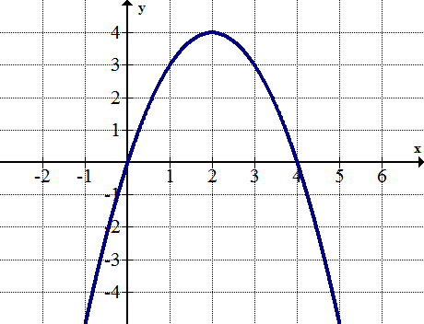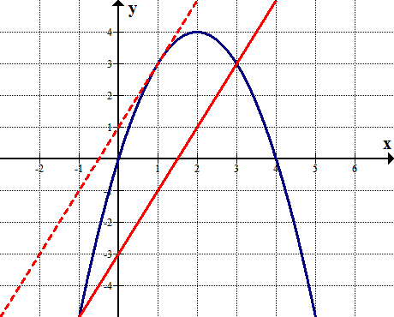

Secant line: 

Tangent line occurs at *x* = 1

on on  on 

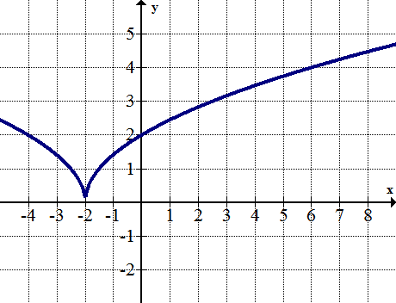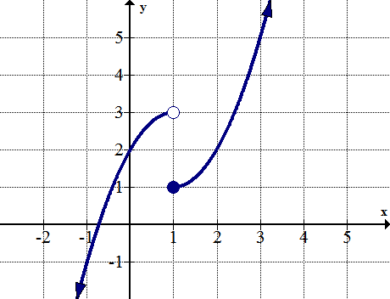

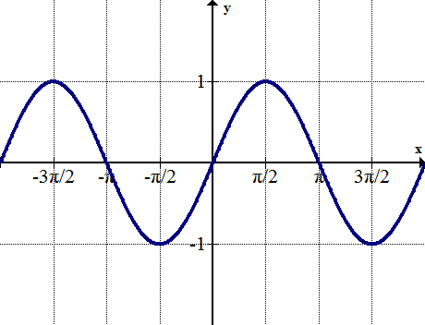  on  on  on 